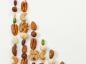
Nut Bars

There are endless variations for this quick & easy no-bake, mostly-raw, no added sugar, fat-bomb
free of major allergens (except nuts!). Fitting for a Keto Diet, which I don’t recommend long term.
Here’s how I originally created the recipe, which changes slightly every time I make it.
Feel free to modify to fit your likes, moods and ingredients on hand.
-----------------------------------------------------------------------------------------------------
¼ cup coconut or other oil, warm }
¼ cup dates, pitted (about 10) } Mash dates into warm oil well
¼ nut and/or seed butter } then mix in nut butter
1 – 1 ½ cups coarse ground raw nuts and seeds } Quick buzz in food processor or coffee grinder
} OR use mortar & pestle or knife on cutting board
{ About ¼ cup each: walnut, pecan, cashew, sunflower, brazil
OR almond, hazelnut; OR pumpkin, sesame, chia seed (seeds may be left whole)}
¼ cup granola or toasted rolled oats
¼ teaspoon salt
Mix everything together well and press firmly (to about 1/2 –inch thick)
into either a pie dish or an 8 x 8 baking dish.
Cut into desired bar size before chilling.
Refrigerate. Best served slightly chilled.
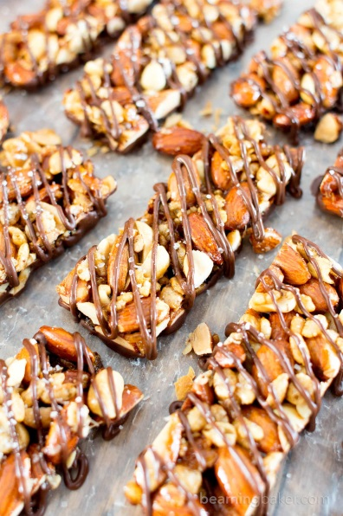
This recipe not pictured-------------------------------------------------------------------------------------
Fudgy Variation, Add into the above mixture
2 - 3 tablespoons cocoa powder
2 - 4 tablespoons dark chocolate shavings or chips

Karl Mincin, Nutritionist * 360.336.2616 * www.Nutrition-Testing.com

