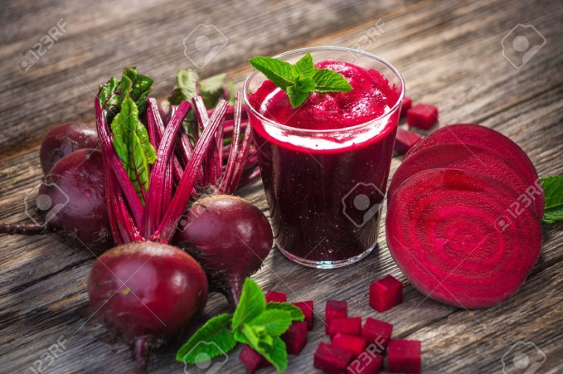
Beet Boost
Stoke your energy metabolism
and athletic performance
while improving liver, heart and brain health
with Nitric Oxide
Karl Mincin, Nutritionist
What do you know about NO? Beets and their juice, along with several other healthy foods, contain plant nitrates, which the body converts to Nitric Oxide (NO) (not animal nitrates found in processed meats which convert to harmful nitrosamine.) NO dilates blood vessels which improves circulation and reduces muscle oxygen requirements thereby increasing maximal oxygen uptake (VO2max). This improves not only cardiac and respiratory endurance and therefore athletic performance, but also helps hypertension and brain health. NO functions literally at the heart of cellular energy production (ATP) in the mitochondria, the body’s energy furnace.
Healthful nitrate-containing foods are one of the best ways to turn up the heat of your energy metabolism. Here are the top ten NO promoting foods: beets, garlic, meat, seafood, dark chocolate, leafy greens (arugula contains twice the amount as cilantro and butterleaf lettuce), rhubarb, citrus fruits, pomegranate, raw nuts and seeds, and watermelon. NO also is available supplementally. Other supplements that have a synergistic effect on NO enhancement include Spirulina, Lipoic Acid, Co-enzyme Q10 and the amino acids Citrulline and Arginine. Arginine also increases growth hormone and insulin. Nutritional bonus from beets: Along with NO, beets are vitamin and mineral dense, phytonutrient-rich and (aside from Dandelion) perhaps the best liver support food available – a veritable powerhouse of nutrition! While NO may be problematic for certain liver disease, the beneficial liver effects of other compounds in beets is well established.
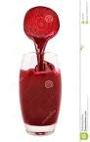
Since NO is fast-acting, in order to maximize the boost it’s best to consume either foods or supplements 30 – 60 minutes before an intense workout or competition. Some research studies have found that caffeine interferes with NO. Because part of the conversion from nitrate to NO is accomplished by saliva enzymes in the mouth, I recommend “chewing” your juice, allowing it to linger in the mouth for rapid and more complete conversion. It’s also best to avoid mouthwash. On the go or on the trail, when away from your juicer or juice bar, beet powder is available. Even if you’re not one of the many athletes who swear by the noticeable performance benefits of NO, there are abundant reasons why this all-around healthy food medicine is worth your while.
Nitric Oxide Juice Recipe (This ain’t no party..! -- but this is a “NO” juice recipe!)
1 medium beet (beetroot)
1/2 cup blueberries OR 1 cup watermelon
1 cucumber
1 handful of spinach
1 handful of arugula
Karl Mincin is a local consulting clinical nutritionist in practice for over 30 years. He specializes in nutrition assessment testing to determine precise individual nutrient needs and also offers highly personalized medical nutrition support. He is available by appointment at Urban Fitness and Health by phone appointment or at 360.336.2616 or www.Nutrition-Testing.com.

