Food Body Part Look-A-Likes
Medicinal Foods and Their Body Part/Organ Counterpart
Foods Resemble the Body Parts They Treat Karl Mincin, Clinical Nutritionist

The lowly kidney bean was my introduction to the food-organ connection. The resemblance is hard to miss. I wonder what this bean was called before we gained x-ray vision into body organs. Yes, Kidney beans contain an amino acid and other cofactors which are good for the kidneys. When I learned that not only do such super foods have organ-specific nutritional properties, they typically contain medicinal phytochemicals targeted to their look-alike organ, this peaked my interest to grow the list. As you can see below, grown it has. If you’re at all familiar with food nutrients and enjoy food art (that is, you like looking closely at and playing with your food almost as much as eating it), you’ll likely be able to add some of your own look-alikes.
Fact is, every organ requires nearly every one of the 72 essential nutrients, more or less of each depending on the organ. Healthy bone is built on much more than calcium, requiring 28 vitamins and minerals. It is similar with food. When attributing health properties to a given food, we tend to isolate, study and highlight only certain nutrient factors while ignoring others even though in the same food. “This flax oil contains omega 3 fats and that olive oil contains omega 9. Reality is each of these contain all of the omegas - 3, 6 and 9 - in varying ratios. We think of meat as protein and grain as carb. All foods, even produce contain all three macronutrients: protein, carbohydrate and fat.
Rather than judge a food by its shape or appearance only, it is best to first determine which selection of targeted foods are most appropriate for your individual nutrient needs given one’s particular biochemistry and any health condition(s). Each person’s nutritional needs are as unique as their fingerprint. One size, or shape, does not fit all. For example, one of the several heart-shaped foods (tomato, grape, pomegranate, etc.) is going to be more relevant for a given individual than are the other similar shaped foods, all of which in theory are cardio protective. Do you need resveratrol (grape) more than lycopene (tomato) for your specific heart condition? Knowing this can be extremely useful, cut through a lot of trial and error guesswork, and in some cases can even mean the difference between life and death. How to find this out is another matter. Doing your homework and research is helpful, but will take a person only so far down the path of individualization. Most of us, after wading through often contradictory studies, are still left with wondering “what of this really applies to me personally?”
Nutritional testing also is a help. I liken the value of testing to your cars dipstick. If you wouldn't add oil to your engine without first checking the dipstick, why eat nutrient-targeted foods or take supplements without first knowing the baseline level you are adding them to? And just as you not add even the best high-grade motor oil without the first checking the level, no matter how wonderful a medicinal food is supposed to be or how top-notch a vitamin supplement claims to be, it only makes common sense to test before you take. Testing allows one to open up the cellular window into the body’s nutrient metabolism, thereby tailoring ones diet and supplementation to your actual need. Establishing your personal nutrition baseline may be the single most important step you take to improving your health. For more info along these individuality lines link here to my two articles?: Establishing Nutritional Baselines and Hair Mineral Analysis: What’s It’s Good For?
So please take the listing below with a grain of sea salt. Notice also the foods not included: You’ll find no animal foods (meat & dairy) and no grains, the mainstay of most Standard American Diets (notice the acronym: SAD, which it truly is!). Not only do such animal foods have far less medicinal value and no real body part correlation (hint hint), they actually contribute to the very diseases that produce protects us from – and instead of bland brown and white, it does so in living color! (* A partial exception is explained below.) In my clinical nutrition practice, I encourage patients to put a rainbow on their plate; eating more veggies is my number one suggestion. It is the single most important dietary change we can make to improve our health. More beans are the second. In case you haven’t heard the latest government recommendation, five servings of produce per day is old news. It’s now nine. Refer to or request my Eat More Veggies article if you’d like some tasty suggestions for incorporating more produce into your diet.
Note that some food-organ resemblance becomes apparent only when the food is sliced or viewed from a certain angle.

TIME TO HEAL: FOOD IS MEDICINE BUT SLOWER THAN DRUGS TO CURE.
It does however, heal deeper and without nasty side effects. Although functional foods of color are increasingly found to have medicinal properties, food does not exert its healing power in drug-like fashion, at the speed of aspirin (20 minutes and the pain is gone). It takes time to heal deeply and safely, on average about three months of regularly eating such foods; more or less depending on the individual condition and the food being used. Some foods are more fast-acting than others and some individuals respond faster than others. Red blood cells for example take 120 days to completely regenerate (their birth-death lifecycle). Skin cells longer. So until all of those cells are fully functioning with the newfound level of nourishment, it can take this amount of time to feel better, lose symptoms and regain organ function. Healing with food happens best and lasts longest when it is made a part of a healthy lifestyle rather than popped like a pill. It’s also critical to take your food medicine properly.
While many people like the idea of using food as medicine, few are willing to do what it takes and really give it a fair chance. I hear too many people tell me “Karl, I took this herb or ate that food for two whole weeks and didn’t notice anything.” They thus quickly conclude “herbs don’t work for me” and it’s back to their prescription drug. Proper dosing also is critical. Folks often make the mistake of not taking enough food medicine, or underdoisng. Blueberries, for example can make a noticeable difference with dementia, but it takes one-half cup per day, day in and day out to impart neurocognitive effects. Many sprinkle a few tablespoonsful on their cereal for a few days and expect miracles. Medicinal herb teas aren’t medicinal at one cup per day. The therapeutic dosage is three cups daily of a properly brewed tea. No dunking the bag just a few times to color the water and calling it good. Medicinal tea is to be steeped five minutes for the above ground plant parts (leaf, flower, berry) and 15 minutes for the below ground portion (root) and bark.

List or chart each:
MEDICINAL PROPERTIES
NUTRITIONAL PROPERTIES

Kidney Bean - Human Kidneys
Kidney beans are large dark-red beans that are shaped like kidneys. They are a high source of soluble and insoluble fiber, protein, sodium, folate, magnesium, iron, thiamin, vitamin B6, zinc and niacin. The beans aid in the functioning of kidneys.

THE DARK SIDE OF BEANS
Legumes have amazing nutritional qualities and are a part of balanced diet. They are high proteins, minerals, dietary fibers and complex carbohydrates and have low fat and cholesterol. We use legumes in our daily life but we are unaware that some legumes contain a toxin known as phytohemagglutinin (PHP) which is very high in kidney beans. One raw kidney bean contains around 70,000 hau and only few raw kidney beans have serious health hazards depending on the sensitivity of the person eating them. This toxin effects the cell metabolism and agglutinates most red blood cells. It attacks epithelial cells lining of the intestine and disables it. Only 5 raw kidney beans can cause reaction within 3 hours including nausea, vomiting and diarrhea. Recovery occurs in 4 to 5 hours. This doesn’t mean that one should stop eating the beans. The beans should be treated and cooked properly to bring the poison to a safe level. If cooked incorrectly the poison increases by many folds. They should be soaked in water for a long time before cooking. Then after throwing that water they should be boiled in fresh water at 100 degrees for 10 minutes or more before simmering to finish cooking until soft.

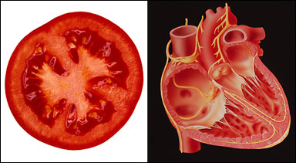
Tomato - Heart
Tomatoes are red or yellow pulpy acidic fruits that are usually eaten as vegetables. They have plenty of vitamin A, vitamin C, folate, sodium and lycopene – a phytonutrient that prevents several cancers, including of the prostate. The Women’s Health Study — an American research program which tracks the health of 40,000 women — found women with the highest blood levels of lycopene had 30 per cent less heart disease than women who had very little lycopene.
Lab experiments have also shown that lycopene helps counter the effect of unhealthy LDL cholesterol. One Canadian study, published in the Journal Experimental Biology and Medicine, said there was “convincing evidence’ that lycopene prevented coronary heart disease.

Like the human heart, a sliced tomato has four chambers. Folate helps in the production of red bleed cells in bone marrow and heme (as in hemoglobin) a protein that helps in transporting oxygen in the blood. Tomatoes therefore, aid in things of the heart. No wonder, they resemble the heart.

Potato - Pancreas
Sweet potatoes are edible starchy tubers that are widely cultivated as vegetables. They look like the pancreas which they treat during diabetic incidents.

Celery & Rhubarb - Bones
Rhubarb is a long green or reddish acidic leafstalk which is consumed after being cooked and sweetened. Celery is a widely cultivated herb with an aromatic leafy stalk that is either consumed raw or cooked. Both crops are at times used as seasoning and contain sodium that strengthens bones. Close scrutiny shows their resemblance with bones

Walnut - Brain
Walnuts are edible nuts which have a wrinkled two-lobed seed that is enclosed in a hard shell. They grow on a walnut tree and contain thiamin, vitamin E and magnesium which aids in nerve functions and muscles. Walnuts help in the development of a neurochemical or organic substance that occurs in neutral activity, which transmits nerve impulses across a synapse or the junction between two neurons.
Neurons are special cells that conduct nerve impulses. The organic substance also helps the transmission of impulses between neurons and muscles in our brains. Uncannily, the wrinkled walnut looks exactly like a miniature brain. It is interesting that a nut that looks like our brain pimps the brain.

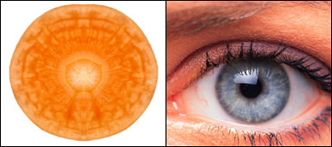
Carrot - Eyes
Carrots serve an important function in our lives. They are a well known source of beta carotene in our diet especially when consumed raw. They contain vitamin A, vitamin C, flavonoids and phytochemicals which serve as antioxidants. Beta carotene helps prevent cataracts in our eyes. A sliced carrot resembles the pupil and iris in our eyes.

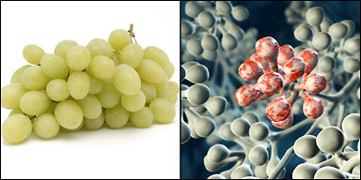
Grapes – Lungs Our lungs are made up of branches of ever-smaller airways that finish up with tiny bunches of tissue called alveoli. These structures, which resemble bunches of grapes, allow oxygen to pass from the lungs to the blood stream. One reason that very premature babies struggle to survive is that these alveoli do not begin to form until week 23 or 24 of pregnancy.
A diet high in fresh fruit, such as grapes, has been shown to reduce the risk of lung cancer and emphysema. Grape seeds also contain a chemical called proanthocyanidin, which appears to reduce the severity of asthma triggered by allergy.

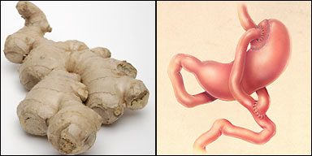
Grapes - Heart
Grapes are juicy, succulent green or purple fruits that grow in a heart-shaped bunch or cluster on a grape vine. They contain sodium, potassium, boron, vitamin C, thiamin and resveratrol – a cholesterol-lowering phytochemical. Various studies have revealed that grapes provide the much needed vitality to the heart, apart from removing cholesterol from our blood.
Ginger Root – Stomach
Helps with nausea and indigestion.
As a vasodilator, ginger opens up blood vessels to the digestive tract allowing increased nutrient absorption.

Onion - Immune System
Onions are bulbous plants with hollow leaves cultivated for its edible bulb. They are rich in vitamin C and B6, iron, biotin and sodium. Onions are famed for lowering blood pressure, cholesterol, fighting cancer and keeping up the body’s immunity. The bulb is usually covered with numerous layers that seem to protect or shield the inner parts of the onion against external objects. It is not surprising to note that the onion shield us by boosting our immunity the same way it seeks to shield itself against external aggression using its numerous layers of protective covers.

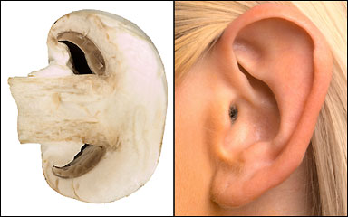
Broccoli – Cancer

Mushrooms – Ears
Slice a mushroom in half and it resembles the shape of the human ear.
And guess what? Adding it to your cooking could actually improve your hearing.
That’s because mushrooms are one of the few foods in our diet that contain vitamin D.
This particular vitamin is important for healthy bones, even the tiny ones in the ear that transmit sound to the brain.

REPRODUCTIVE

Orange, citrus fruits and Mammary glands
Oranges are round citrus fruits whose color tends from yellow to orange. They are a very good source of vitamin C, pectin, terpenes and folate. The last two combat cholesterol. Oranges help in keeping mammary glands healthy while speeding up the movement of fluids therein. When carefully scrutinized, oranges resemble mammary glands or female breasts.

Avocado, Pear and the Womb
Avocados are large pear-shaped pulpy green or dark fruits enclosing a single equally large seed. They contain mono-saturated fats that fight cholesterol, lutein which fights muscular degeneration, vitamin C and E. Pears on the other hand are sweet juicy gritty-textured fruits containing vitamin C, sodium, water and fiber. They are also high in kilojoules. The consumption of avocado balances hormones, lowers birth weight while preventing cancer of the cervix. Both fruits are shaped like the womb they treat.

Zucchini, Banana, Cucumber and Masculine genitalia
Cucumber is a cylindrical green fruit with a thin rind and white flesh which is related to melons and is consumed as a vegetable. Bananas are long crescent-shaped yellow fruits with soft sweet flesh. They are rich in potassium, vitamin C and B6. These foods have nutrients that strengthen men’s genitalia.

Fig and Masculine genitalia
Figs are sweet pear-shaped seedy fruits with yellow or purple flesh. They are mineral rich, potent with potassium, manganese, iron and calcium. They are consumed fresh or dried. Figs grow in pairs, and have many seeds. They are credited with increasing both the number and life span of sperms while eliminating sterility. An uncanny resemblance of male genitalia while aiding in that direction.

Peanut and the male seed
Peanuts or groundnuts are legumes grown underground in a pod or shell by a peanut vine. They are rich in vitamin E and B6, niacin, magnesium and folate. They are good at lowering the risk of heart disease, courtesy of the antioxidant, resveratrol found in its skin. The skin also contains arginine, the key ingredient in potency drugs. The nuts shell resembles spermatozoa.
Seeds also are excellent for the male seed and reproductive health. Along with essential fatty acids, raw Sunflower, Pumpkin, Sesame and all other seeds are rich in zinc, which is to men what iron is to women. Zinc loss through ejaculatory semen is significant.

Olive and the Ovary
Olives are small oval single seeded fruits produced by the olive tree. They are cherished as food and as a source of oil. Olives are rich in nutrients that greatly assist the ovary that they resemble.

There are many other foods that resemble body organs they seem to preserve. Let your next shopping spree be filled with insight prior to your making purchases.

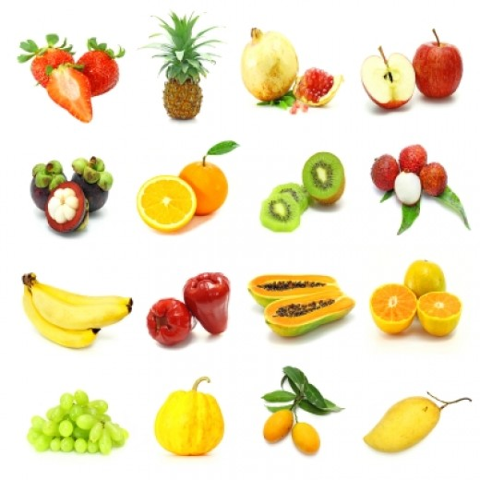
Create a whole produce person organ matched.

Intro
This article tries to show how we can tell the benefit of a particular type of food to our bodies by scrutinizing the shape of the food. We might not be aware of the usefulness of a particular type of food. We may not even know the nutritional aspects of certain foods. But, a simple look at some foods reveals much more than we expect from the food itself.
Just like human beings on earth, the foods we consume come in various shapes, color and form. It is however, interesting to note that some food’s appearance or shapes tell much more than meets the eye. When we consume food, rarely do we think about the food in terms of the function it will accomplish in our bodies, and specifically, in our body organs.
Scientists have proved that some foods have a link with body organs that are shaped like these foods. Such foods have adopted an uncanny resemblance to some body organs in man, thereby revealing a very interesting aspect of human life and plant forms. Research indicates that these foods provide a cure for ailments that afflict the body organs they resemble.

1. MUSHROOM – EAR
Slice a mushroom in half and it resembles the shape of the human ear.
And guess what? Adding it to your cooking could actually improve your hearing.
That’s because mushrooms are one of the few foods in our diet that contain vitamin D.
This particular vitamin is important for healthy bones, even the tiny ones in the ear that transmit sound to the brain.

2. BANANA - SMILE (LIPS)

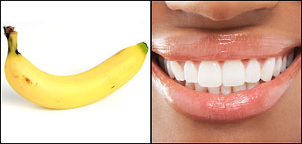
Cheer yourself up and put a smile on your face by eating a banana.
The popular fruit contains a protein called tryptophan.
Once it has been digested, tryptophan then gets converted in a chemical neurotransmitter called serotonin.
This is one of the most important mood-regulating chemicals in the brain and most anti-depressant drugs work by adjusting levels of serotonin production.
Higher levels are associated with better moods.

3. BROCCOLI – CANCER
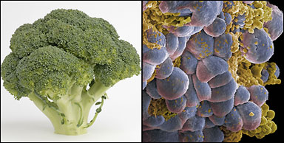
Close-up, the tiny green tips on a broccoli he ad look like hundreds of cancer cells.
Now scientists know this disease-busting veg can play a crucial role in preventing the disease.
Last year, a team of researchers at the US National Cancer Institute found just a weekly serving of broccoli was enough to reduce the risk of prostate cancer by 45 per cent.
In Britain , prostate cancer kills one man every hour.

4. GINGER – STOMACH
Root ginger, commonly sold in supermarkets, often looks just like the stomach.
So it’s interesting that one of its biggest benefits is aiding digestion.
The Chinese have been using it for over 2,000 years to calm the stomach and cure nausea, while it is also a popular remedy for motion sickness.
But the benefits could go much further.
Tests on mice at the University of Minnesota found injecting the chemical that gives ginger its flavor slowed down the growth rate of bowel tumors.

5. CHEESE – BONES
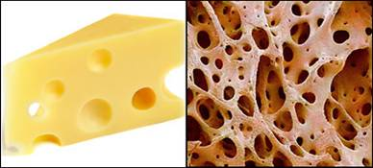
A nice ‘holey’ cheese, like Emmenthal, is not just good for your bones, it even resembles their internal structure.
And like most cheeses, it is a rich source of calcium, a vital ingredient for strong bones and reducing the risk of osteoporosis later in life.
Together with another mineral called phosphate, it provides the main strength in bones but also helps to ‘power’ muscles.
Getting enough calcium in the diet during childhood is crucial for strong bones.
A study at Columbia University in New York showed teens who increased calcium intake from 800mg a day to 1200mg – equal to an extra two slices of cheddar – boosted their bone density by six per cent.
Allow me step up on my Anti-Dairy Soapbox:
The cheese-bone health connection is interesting but not necessarily true. I’ve excluded the picture from my post because I do not believe that milk (and dairy products) is good for every body. In fact, good medical research shows that it actually contributes to or even causes many of the diseases it is claimed to prevent or protect against. While I’ve written extensively elsewhere on this subject, briefly although dairy contains abundant calcium, it is either imbalanced or blatantly deficient in the other 27 nutrients and co-factors that go into the body’s construction of healthy bone tissue. Additionally, most people are familiar with the mucous / congesting effect of dairy products. This occurs not only where we notice it in sinus and throat, but also the digestive and reproductive tracts, and can cause significant problems there. Dairy is one to the top five allergens. So, if I were to post a picture of Swiss cheese alongside the bone matrix, it would be a slice with very large holes, like the kind it can make in your bone! In other words holy cheese may = holy bones.
Non-dairy Bone Food
Celery & Rhubarb - Bones
These stout stalks will do far more good for bone strength than dairy products. Rhubarb is a long green or reddish acidic leafstalk which is consumed after being cooked and sweetened. Celery is a widely cultivated herb with an aromatic leafy stalk that is either consumed raw or cooked. Both crops are at times used as seasoning and contain a healthy form of sodium and other minerals that strengthens bones. Close scrutiny shows their resemblance to reinforced bones.
+ Dark Greens, cup for cup, contain nearly the same amount of calcium as milk and, the real plus is that they are much more balanced in terms of all of the other related bone nutrient co-factors. Broccoli also is excellent bone food and far more mineral balanced than dairy products.

6. GRAPES – LUNGS
OUR lungs are made up of branches of ever-smaller airways that finish up with tiny bunches of tissue called alveoli. These structures, which resemble bunches of grapes, allow oxygen to pass from the lungs to the blood stream. One reason that very premature babies struggle to survive is that these alveoli do not begin to form until week 23 or 24 of pregnancy.
A diet high in fresh fruit, such as grapes, has been shown to reduce the risk of lung cancer and emphysema.
Grape seeds also contain a chemical called proanthocyanidin, which appears to reduce the severity of asthma triggered by allergy.

7. TOMATO – HEART
A TOMATO is red and usually has four chambers, just like our heart.
Tomatoes are also a great source of lycopene, a plant chemical that reduces the risk of heart disease and several cancers.
The Women’s Health Study — an American research program which tracks the health of 40,000 women — found women with the highest blood levels of lycopene had 30 per cent less heart disease than women who h ad very little lycopene.
Lab experiments have also shown that lycopene helps counter the effect of unhealthy LDL cholesterol.
One Canadian study, published in the Journal Experimental Biology and Medicine, said there was “convincing evidence’ that lycopene prevented coronary heart disease.

8. WALNUT – BRAIN
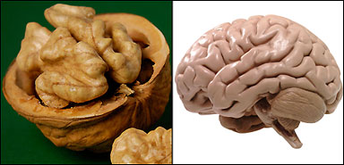
THE gnarled folds of a walnut mimic the appearance of a human brain – and provide a clue to the benefits.
Walnuts are the only nuts which contain significant amounts of omega-3 fatty acids.
They may also help head off dementia. An American study found that walnut extract broke down the protein-based plaques associated with Alzheimer’s disease.
Researchers at Tufts University in Boston found walnuts reversed some signs of brain ageing in rats.

9. CARROT – EYES
Slice a carrot and it looks just like an eye, right down to the pattern of the iris. It’s a clear clue to the importance this everyday veg has for vision. Carrots get their orange color from a plant chemical called beta-carotene, which reduces the risk of developing cataracts. The chemical also protects against macular degeneration an age-related sight problem that affects one in four over-65s. It is the most common cause of blindness in Britain. But popping a beta-carotene pill doesn’t have the same effect, say scientists at Johns Hopkins Hospital in Baltimore . It is definitely some combination of this chemical with constituents of carrot that make it uniquely beneficial for your eyes.

ON THE DARK SIDE – Not so bright, colorful and healthful
Potato is the most favorite vegetable among the masses, especially enjoyed by children. They can be prepared in a variety of ways. Potatoes are rich in iron, vitamin C, copper, dietary fibers and many other nutrients. They contain substances known as glycoalkaloids. Most common glycoalkaloids in potatoes are solanine and chaconine. The stem and leaves of the potato plant are highly poisonous. The green raw potato is poisonous and death can occur by eating large amount of raw potato. Potato poisoning is rare, but it does happen from time to time. The initial symptoms are weakness and confusion, followed by a coma. To avoid the poisoning, raw potato should not be eaten and potato should always be cooked properly before eating.

Toadstool Poisonous Mushroom
Mushrooms are a type of fungus. They are high in protein and dietary fiber. They can became a source of vitamin D if exposed to ultraviolet light. There are few types of mushrooms which are highly poisonous and the effects range from gastrointestinal distress to death. It is very important to correctly identify the poisonous variety of the mushroom in order to avoid the poisoning. Some very expert mushroom collectors have suffered from mushroom poisoning. 32 species of mushrooms cause fatality and 52 have high poison content. It is very important to eat mushroom only if it is from a very reliable collector. Few features which can help in distinguishing the poisonous ones from the nonpoisonous ones are that they have flat top, red or pink gills which stay on the top and no bumps.

1/13
rev 5/16

