High prevalence of vitamin D deficiency among children worldwide
Nutrition plays a vital role in the proper growth and development for children. Unfortunately, your child cannot receive enough vitamin D from dietary sources alone. Instead, like adults, children must rely on sunshine and supplements to maintain healthy vitamin D levels. Research consistently shows that many children, regardless of where they are from, are vitamin D deficient. It’s difficult enough to ensure that your child receives a well-balanced diet, but what happens when a child cannot obtain adequate amounts of a vitamin from their diet?
Severe vitamin D deficiency in children causes rickets. Vitamin D increases the absorption of calcium and phosphorous from the gastrointestinal tract. If calcium and phosphorous levels are too low, the body produces hormones to release these minerals from the bones, leading to weak and soft bones. This disorder was very common in the late 1800’s. But as the scientific community discovered more about the etiology of rickets, its rate had declined.
However, a study from 2014 found that the rate of rickets is back on the rise in the United Kingdom. In fact, the researchers found that the rate of hospital admissions due to rickets was the highest it had been since the 1960’s.
Research from the past decade has discovered that rickets is not the only potential consequence of vitamin D deficiency. Studies have shown that vitamin D deficiency places children at an increased risk for allergies, eczema, autism, growing pains, infections and cavities.
Sadly, despite the increased evidence of vitamin D’s important role in children’s health, the prevalence of childhood vitamin D deficiency remains high throughout the world.
Look at the map below, which illustrates the shocking prevalence of vitamin D deficiency in children worldwide. Keep in mind that vitamin D deficiency, as shown by the map, is defined by levels below 20 ng/ml. However, the Vitamin D Council recommends that children and adults maintain vitamin D levels between 40-80 ng/ml.
So, how do we solve this threat to public health? The Vitamin D Council aims to spread evidence based information worldwide. As vitamin D awareness increases, more people will begin taking proactive approaches to their health and vitamin D levels. The second step is to supply vitamin D to those without the resources to purchase it. Companies, such as Biotech Pharmacal, donate their supplements for various public health initiatives aimed at supplying individuals with the vitamin D they need, including Vitamin D Council’s local outreach.
While curing the vitamin D deficiency pandemic may be a distant goal, you can take the necessary steps to ensure your child is receiving enough vitamin D:
- Begin supplementing your child with 1,000 IU of vitamin D per 25 pounds of body weight.
- After two months of supplementation, test your child’s vitamin D levels. (The Vitamin D Council offers a 25(OH)D in-home test kit for the most affordable price in the U.S.)
- If your child is not within the optimal range of 40-80 ng/ml (50 ng/ml is ideal), then adjust their supplementation regimen accordingly. Retest their vitamin D levels two months after making any changes to their supplementation regimen.
Don’t forget to check with your doctors first to find out whether your child can supplement with vitamin D. Certain health conditions and medications can conflict with taking vitamin D.
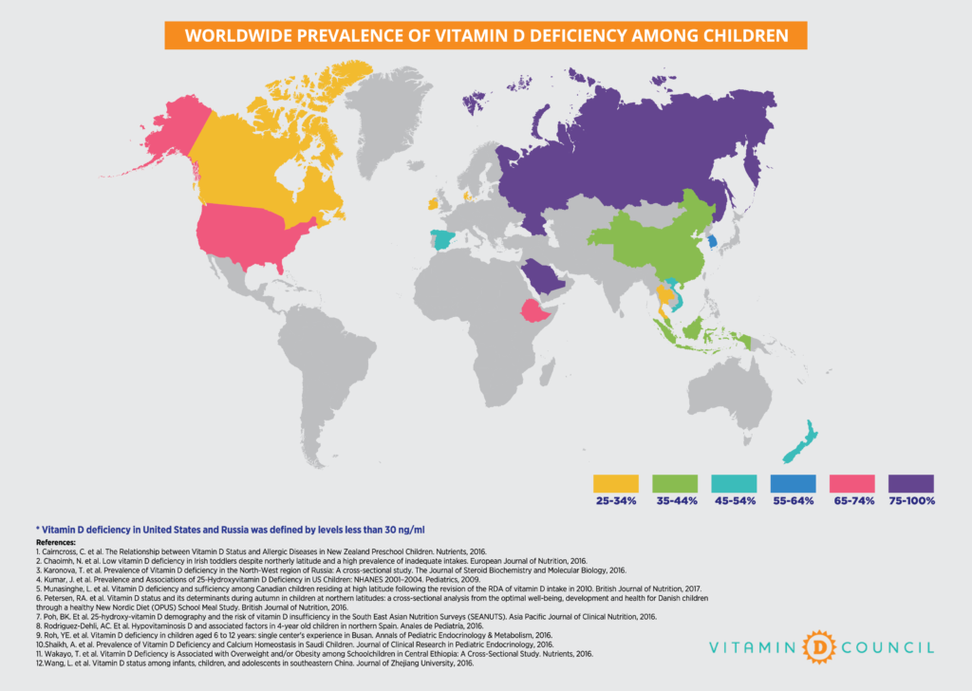
Citation
Tovey, A. & Cannell, JJ. High prevalence of vitamin D deficiency among children worldwide. The Vitamin D Council Blog & Newsletter, 3/2017.
Posted on: March 27, 2017 by Amber Tovey

