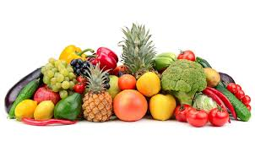
Protein from Veggies
Protein is not spelled m-e-a-t. Time to veg out!
All we are saying is “give peas a chance”
Karl Mincin, Clinical Nutritionist

Before you bake that chicken breast after your next workout, take a second look at the protein content of vegetables. Veggies average 5 grams of protein per cup. Some have as much as 8 grams. That may pale in comparison to a chicken breast (24 grams per 3 ounces), but vegetables far outweigh not only nutritional value but overall health properties. This includes fiber, antioxidant phytonutrients, vitamins and minerals. They’re also more affordable sources of protein and micronutrients than fish and beef.

People who consume higher amounts of vegetable protein are significantly less susceptible to excess belly fat, high blood pressure, high cholesterol, cancer, arthritis, and other diseases than those who skimp on produce, according to a study published in the journal Diabetes Investigation. Another study in Food and Nutrition Research found that plant protein helps dieters feel fuller and less hungry than the same amount of animal protein.
Looking to reap the fat busting and health benefits? Listed below are the most popular veggies on your plate and ranked according to their protein content. So whether you’re a vegetarian or an omnivore just looking to pack on the protein without having to scarf down another chicken breast, keep this handy guide to always have your go-to plant-based sources on hand. Adding these veggies to your diet will help you reach your body goals better than meat alone.
As explained in my article Eat & Enjoy More Vegetables, the current recommendation for servings of produce is nine per day. Since a serving is typically one-half cup, and veggies average five grams of protein per cup, consuming your daily veg quota will supply about 23 grams of protein, the same as a serving of chicken. So don’t forget to factor veggies into your total daily protein intake. Remember, protein is not spelled m-e-a-t. If you struggle to get your daily veg requirement, as most of us do, this article includes tips for tasty ways to enjoy more of my number one recommended health food.

Approximate grams of protein per cup
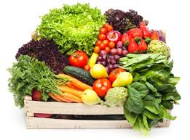
LOW (0.5 – 2 gm)
Bell Pepper
Carrot
Beet Greens
Eggplant
MEDIUM (3 – 5 gm)
Asparagus
Corn
Sweet Potato
Brussels Sprouts
Mushrooms
Broccoli
Avocado
Cauliflower
Zucchini
HIGH (6 – 8 gm)
Green Peas
Russet Potato
Collard Greens
Squash, Hubbard
Spinach

Karl Mincin is a clinical nutritionist and natural health educator in practice locally for over 30 years. With a personalized approach he offers both preventive and therapeutic nutrition counseling, specializing in nutrition assessment testing, the process of determining individual nutrient needs and body chemistry balance. He may be reached at (360) 336-2616 www.Nutrition-Testing.com

